Office 365 Information 2015

Understanding the cloud vs. your local network (short Power Point)

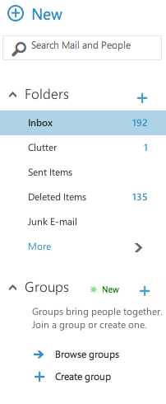
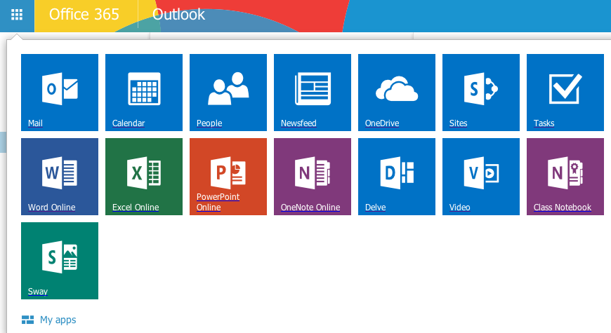
On the Bonduel School District home page, go to “Staff Resources” and then “Staff Email.” Log in using your user name and password. When you come to your email, you can click the box that looks like a Rubik’s cube in the corner to see all that Office 365 has to offer.

Email

- You can create a new email.
- You can search for mail or the email addresses of people in the district or people with whom you may have emailed in the past.
- You can manage your folders.
- You can create groups. This is a great feature to use as a classroom teacher, club advisor, or coach. You can email all of the students or teachers in your group to send out information about an assignment, a practice schedule, etc. You can share a calendar with all of the important dates for your group.
- It is easy to set up a group, and it is a valuable communication tool.

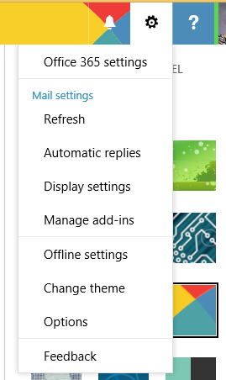
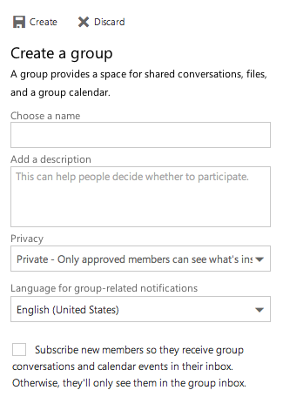
Managing your preferences: Under the wheel on the top right of your screen, you can change your theme, manage your display settings, and set all of your preferences.

You can get your email on your smart phone by downloading an app called OWA.

People are your contacts. You should be able to search for the email addresses of all teachers and students in the district.

Use the Calendar to keep track of all of your special events. You will get a pop up reminder on your computer or phone to keep you on track.
- After school meeting
- IEPs
- dates when you are subbing for a colleague

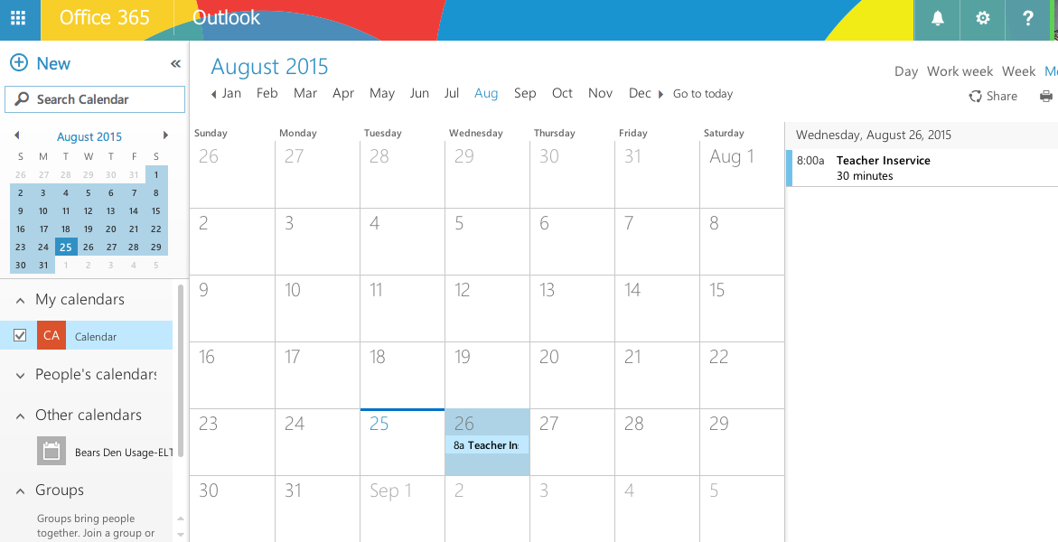
In Newsfeed, you can create a blog or follow other people. It allows you to keep track of topics, schedules, other users, and conversations all on one webpage.

You will receive One Drive training in another session.

In Sites, you can create a public web site or keep track of other web sites that you want to follow.

Tasks is a great tool if you like to keep to-do lists. You can add a new task, choose the due date, and mark as complete by clicking on the flag.
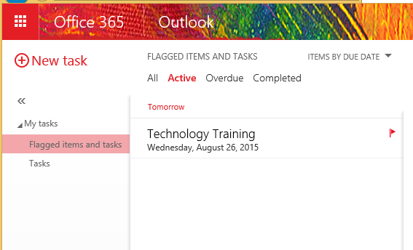

There are online versions of Microsoft Word, Power Point, Excel, and One Note available, which is great if your home computer or phone does not have these programs.

Delve shows the last documents that you have been working on in Office 365. If you click on “ME” and “Activity,” you will see the last few items that you have been working on. This is great for students who can’t remember in what folder they saved a document, as long as they saved to their One Drive account.

See the example on the next page:
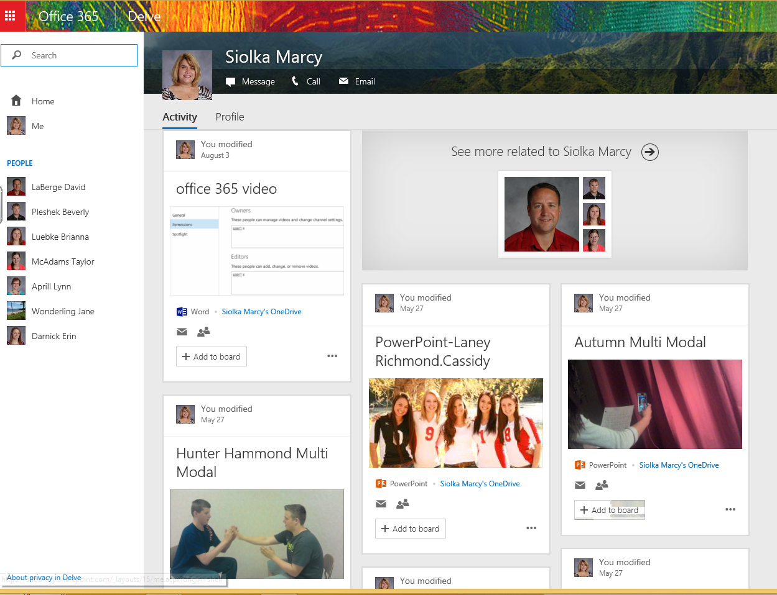

Video allows you to upload videos that you have created for your students or other staff members to view. The school can even set up your own channel if you want to do a flipped classroom.

Class Notebook allows teachers to quickly set up a personal workspace for every student, provides a content library for handouts and a collaboration space for lessons and creative activities. Students can take notes by placing images, text, printouts, tables, ink, screenshots and files in OneNote’s “anything, anywhere” freeform canvas. You can get more ideas on how to use Class Notebook at http://onenoteforteachers.com/.
Sway lets you create and share interactive reports, presentations, personal stories, newsletters, vacation memories, school and work projects, and more. If you click on the word “Tutorials” in the right hand corner, there are some tutorials on You Tube that will show you how to use Sway.

